**Publish Over SSH**  
  
Visit github.com and log in.

Click on "New" to create a new repository.  
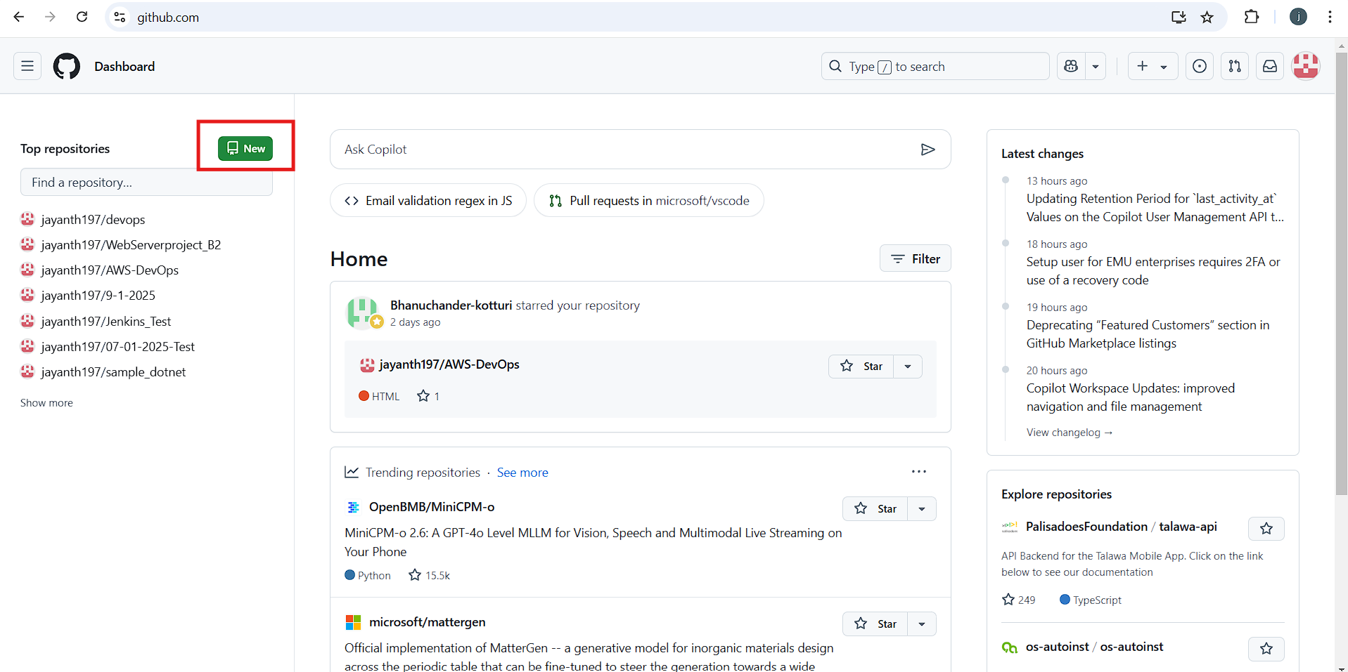  
  
  
Provide a repository name and description.

Select "Private" and click "Create" to set up your repository.  
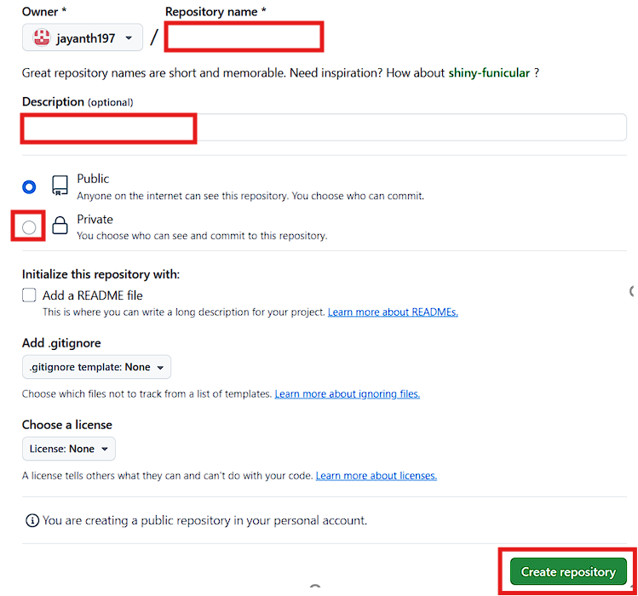

Go to your repository and click on "Code" to copy the HTTPS URL.  
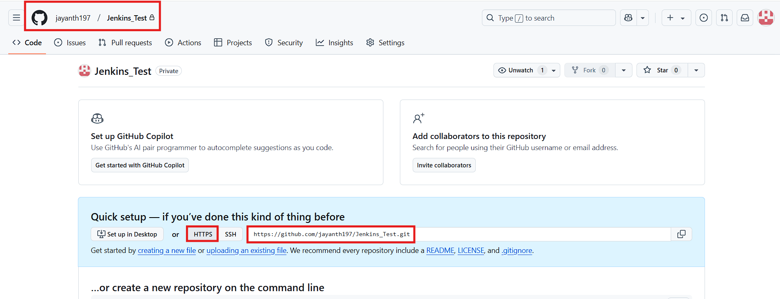  
  
  
Open Git Bash in the desired local path and clone the repository using git bash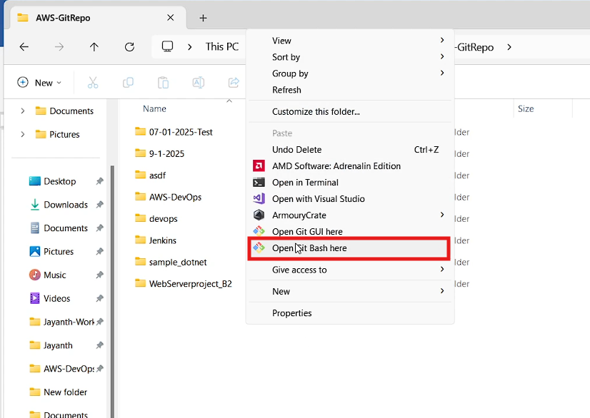  
  
  
  
  
  
entering the following command  
git clone  
  
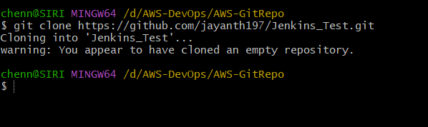  
  
repository, e.g., https://github.com/jayanth197/AWS-DevOps.git  
  
same way clone the abpve repository in your local then you will see file like below  
  
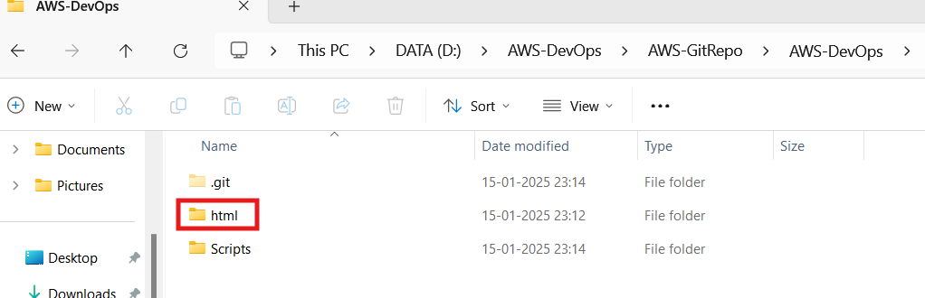  
  
in the html folder there are some html files copy those files and paste it into your cloned repository  
  
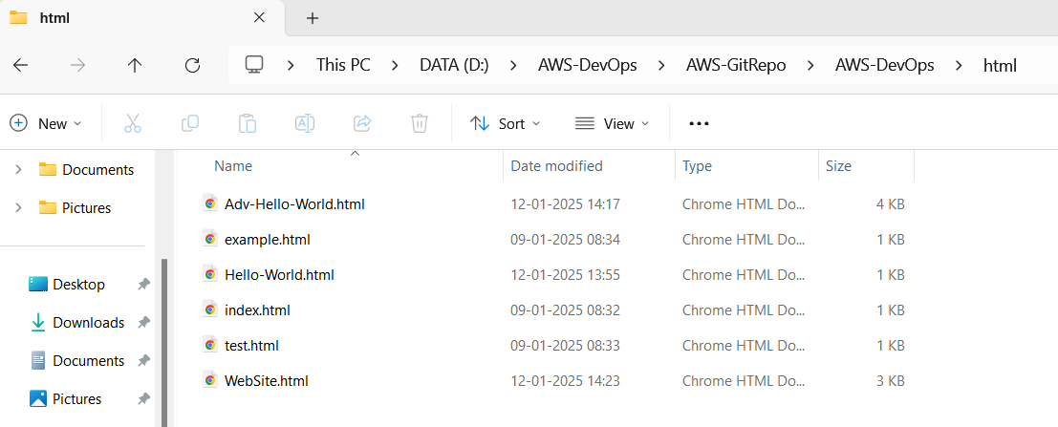  
  
  
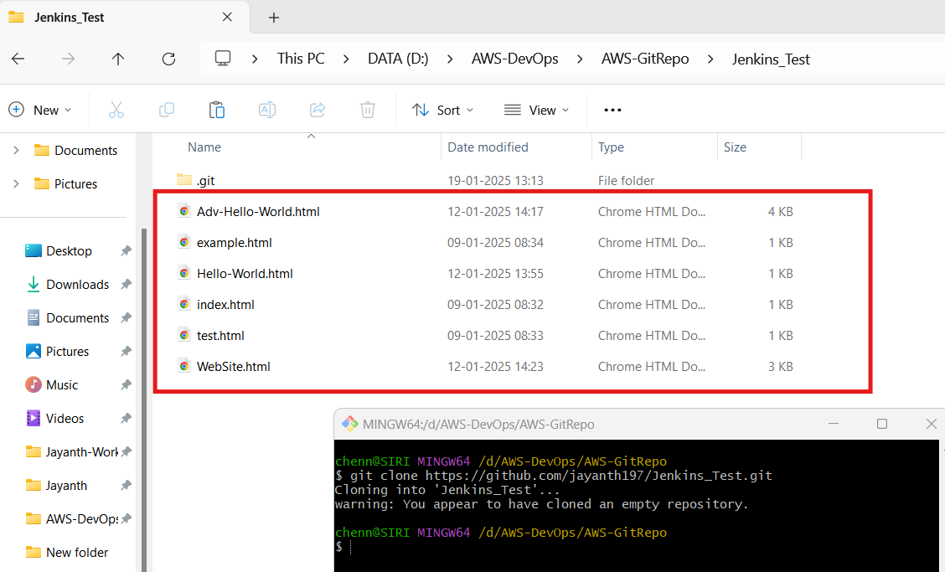  
  
  
Use the following commands to add, commit, and push the changes:  
git add .

git status

git commit -m "Test Files"

git push  
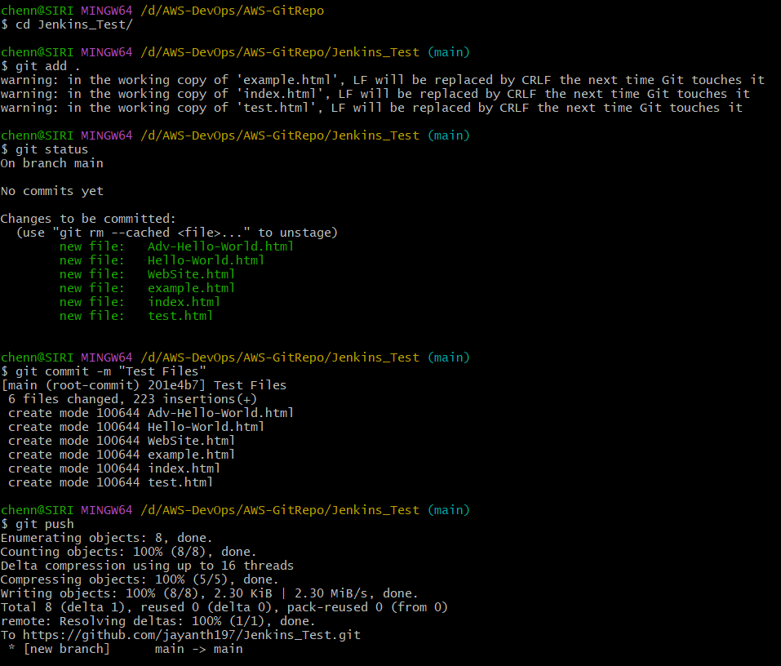  
now go to your repository then you will see the newly created files in the repository  
  
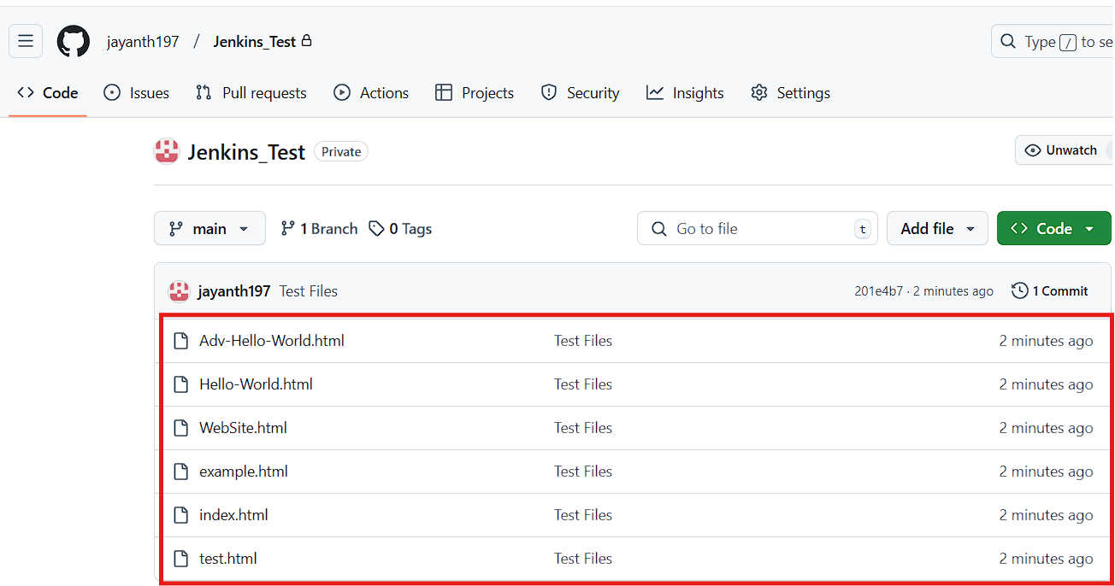  
  
Log in to the Jenkins dashboard.  
  
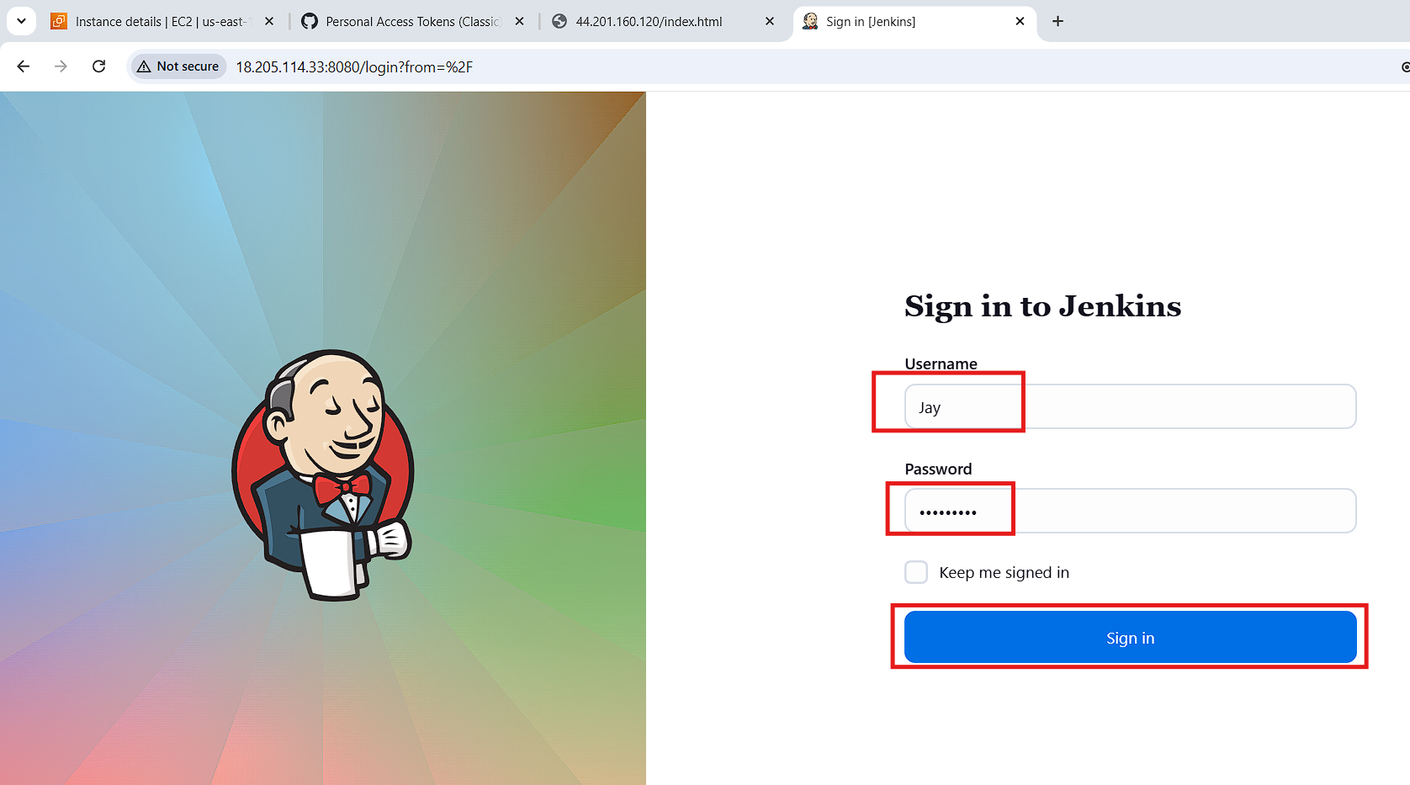

Click on manage Jenkins  
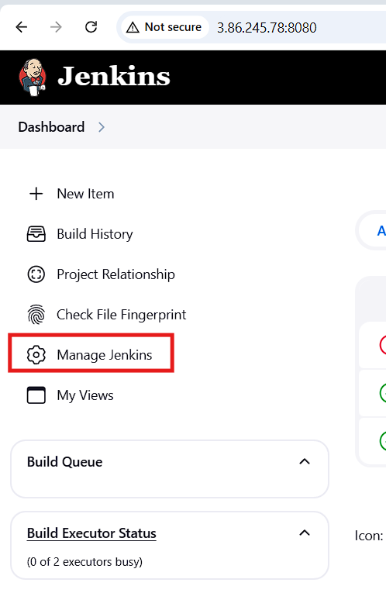  
  
  
  
In the system configuration click on plugins  
  
  
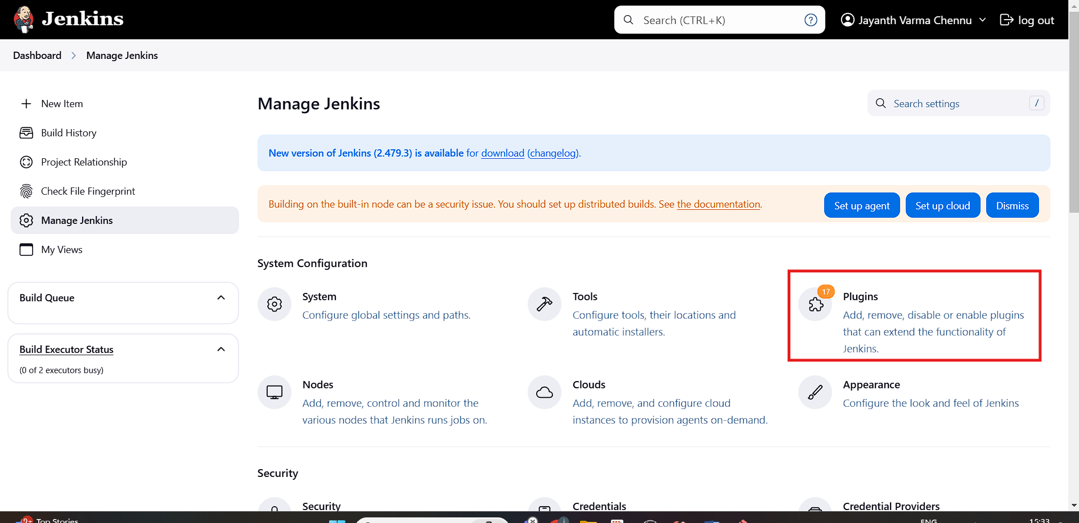  
  
  
  
In the available section search for publish over ssh plugin and click on install without restart  
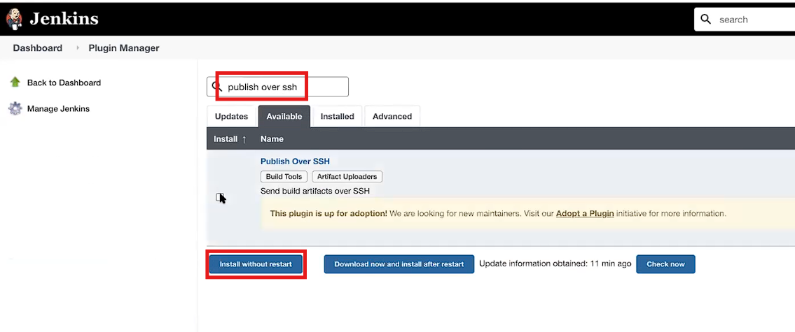  
In the system configurations select system  
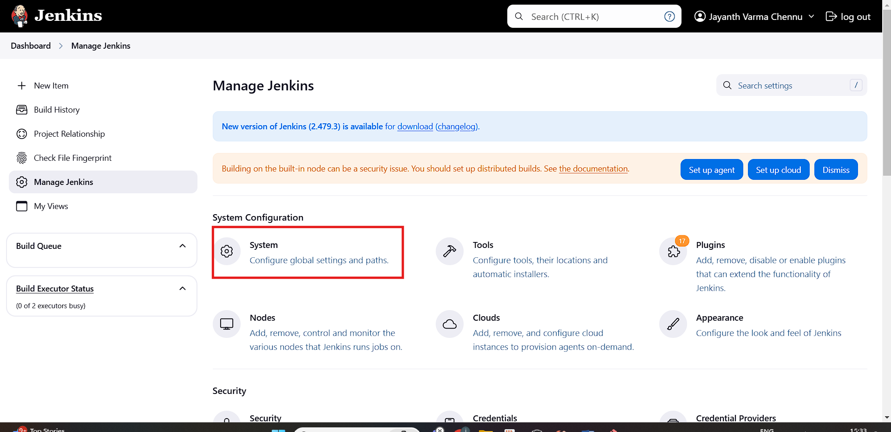  
  
in the publish over SSH section give the details shown below  
/root/.ssh/id_rsa path  
  
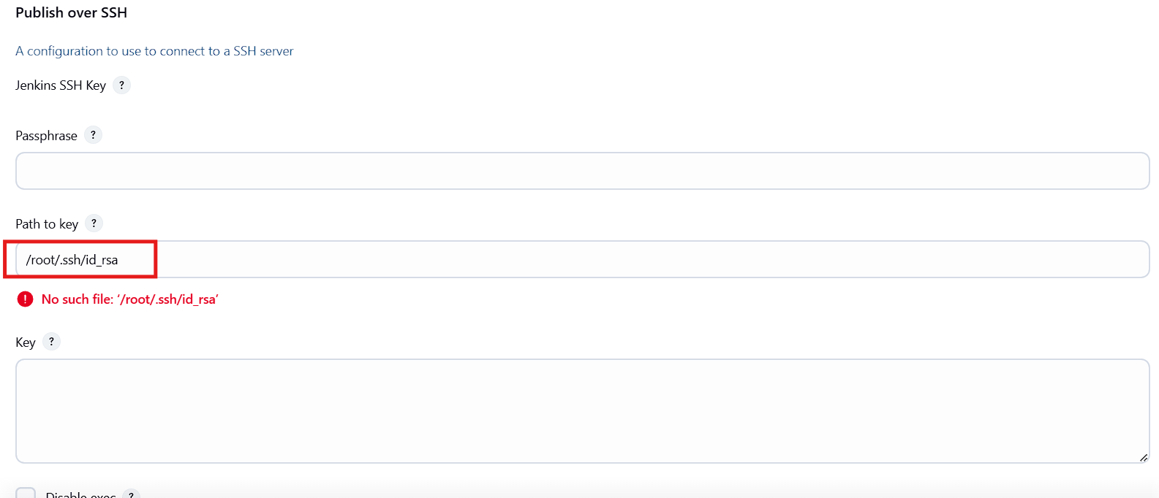  
  
click on add  
  
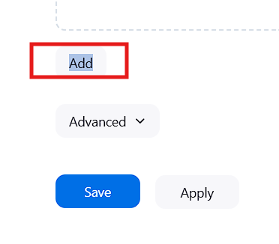  
  
  
  
Provide the name of your web server (any name you prefer). In the hostname, enter the web server's private IP as shown below. Specify the username and the remote directory you created on the web server.  
  
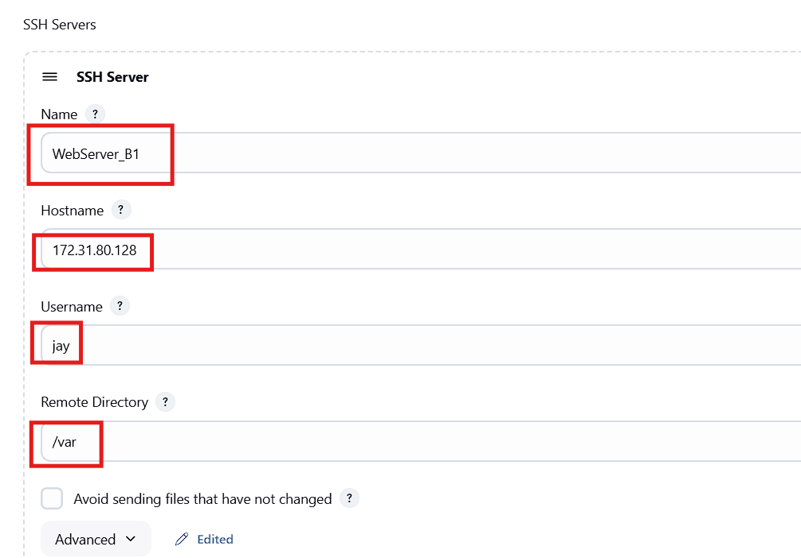  
  
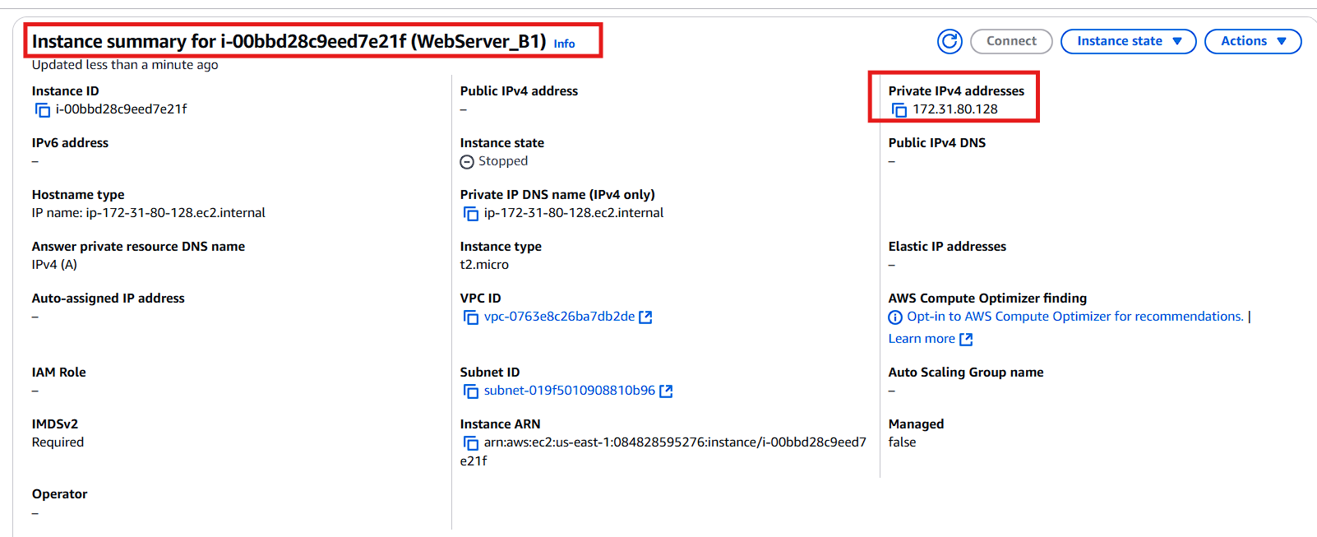  
  
  
  
Click on "New Item", enter a job name, select "Freestyle project", and click "OK".  
  
  
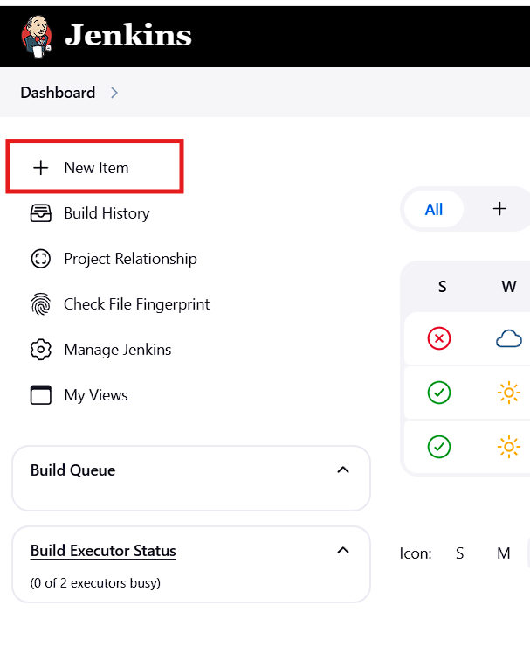  
  
  
  
Give the project name click on freestyle project and click on ok  
  
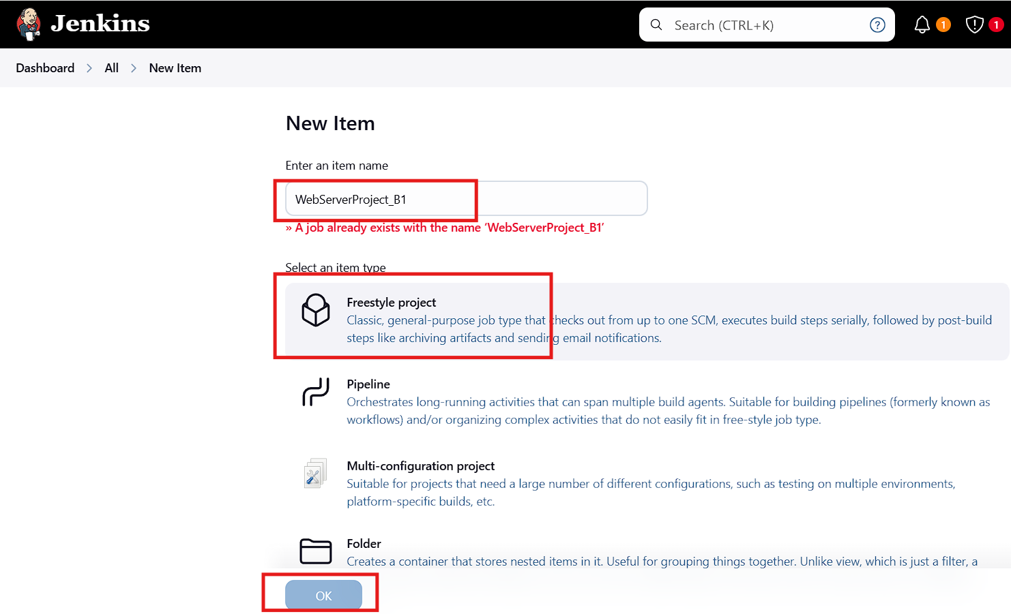  
  
  
give the repository url and provide the credentials make sure you give the main in the branch  
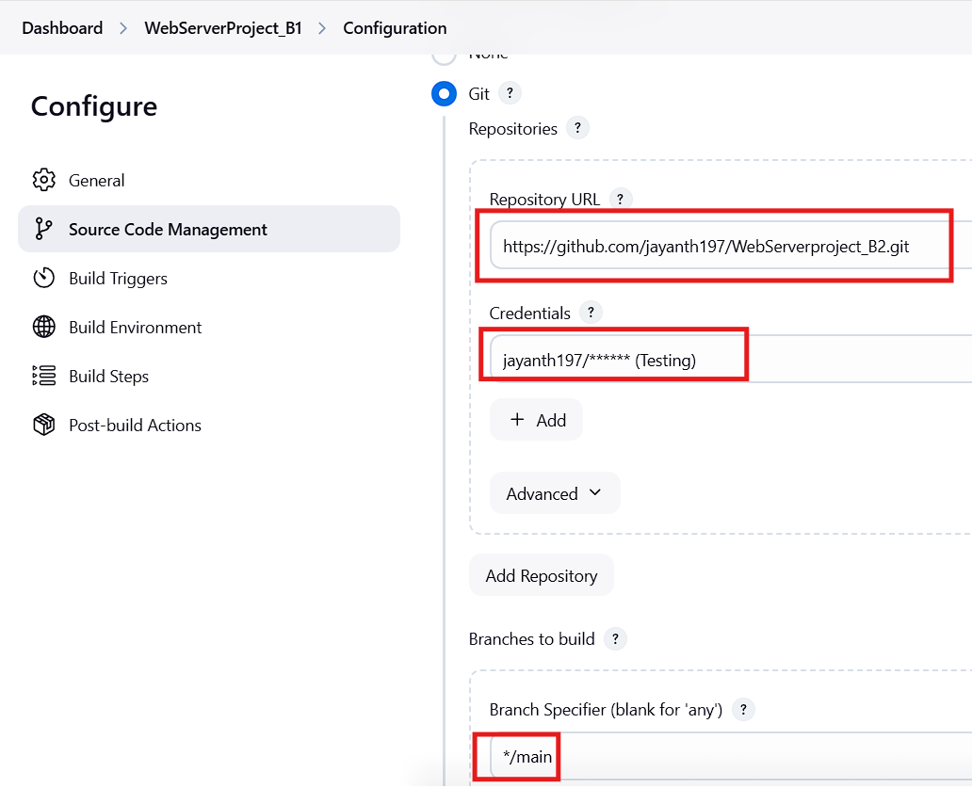  
  
  
click on add build step and select send files or execute commands over ssh  
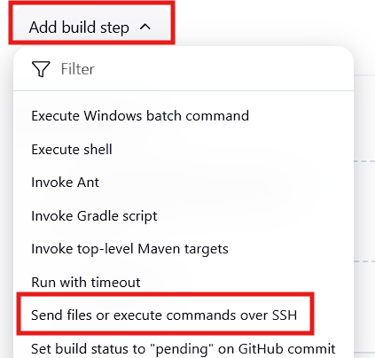  
  
  
  
click on the name then you will see the ssh webserver that you have configured in the system configuration and provide the details as shown below  
  
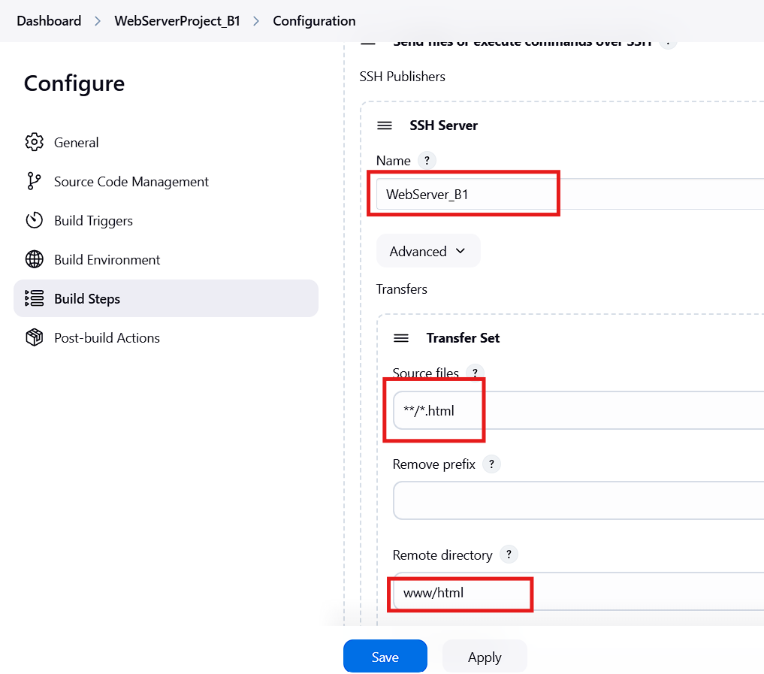  
click on add post-build-action and select send build artifacts over SSH  
  
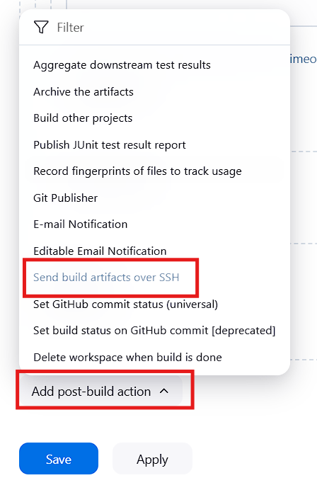  
  
  
Give the details as shown below and click on apply and save  
  
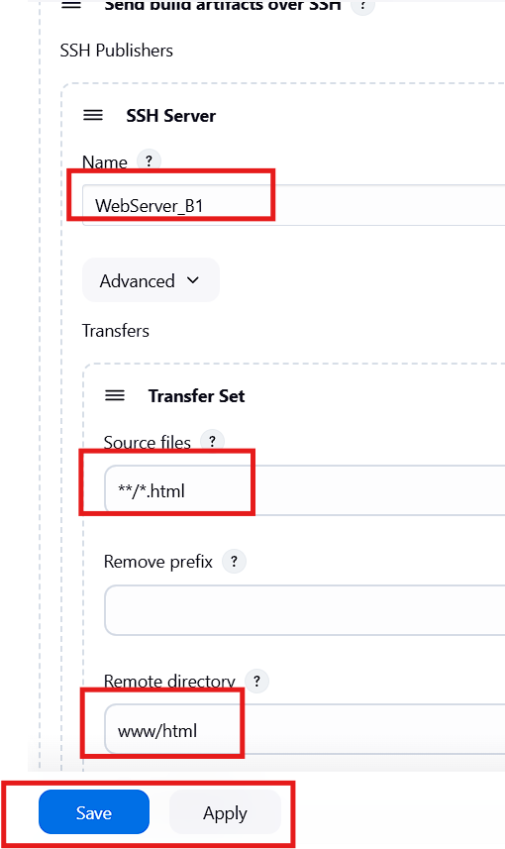  
click on build now   
  
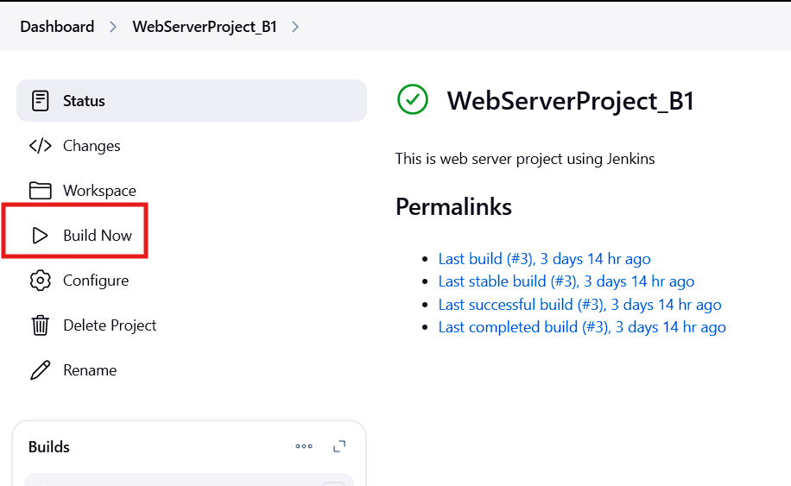  
  
  
  
once the build is successful copy the public ip of the webserver and searches with the below example URL  
<http://(public> ip)/your html file  
then you will see the HTML pages in the browser  
